How To Create A Custom Preloading Screen
Are you building a one page parallax scrolling website and getting concerned about your page load time?
Lets be honest, the one page websites can get quite bulky very quickly even when you optimize everything.

How To Create A Custom Preloading Screen
Are you building a one page parallax scrolling website and getting concerned about your page load time?
Lets be honest, the one page websites can get quite bulky very quickly even when you optimize everything.
You might be also interested in How To Make Page Transitions in HTML – Barba.js and GSAP3 Tutorial

Related Screencast

One option to reduce the frustration of your users is to add a nice custom preloader screen.
View Demo →Download Files ↓
In this tutorial we will add a CSS3 transitions to our already created CSS3 preloader.
Once the content of the page is loaded, we’ll animate the preloading screen away from the viewport with a nice transition.
What you will learn
- how to use CSS3 transitions
- how to animate out a full-screen preloader
- how to combine CSS3 with JavaScript for this technique
Open the starting files and follow the steps below.

1. Add HTML and CSS for loading overlay

In our index.html is an existing CSS3 preloader #loader on a white background, but we want to create a high contrast between preload screen and the content.
Lets add two parts of the preloading screen inside of #loader-wrapper.
01  02  03  04  05  06  07 | <div id="loader-wrapper">  <div id="loader"></div>  <div class="loader-section section-left"></div>  <div class="loader-section section-right"></div>  </div>

Now we’ll add some CSS into the css/main.css, just after the @keyframes spin declaration.
01  02  03  04  05  06  07  08  09  10  11  12  13  14  15  16 | #loader-wrapper .loader-section {  position: fixed;  top: 0;  width: 51%;  height: 100%;  background: #222222;  z-index: 1000;  }  #loader-wrapper .loader-section.section-left {  left: 0;  }  #loader-wrapper .loader-section.section-right {  right: 0;  }

This creates a full screen dark overlay, but unfortunately it also covers our rotating #loader and makes the page title hard to read.

CSS Tweaks
We will need to tweak the z-index of #loader to bring it above our dark overlay and change the color of our heading to light grey.
Find #loader in the stylesheet (line 43) and add the following style, also include the h1 style just below our default p styles (line 34).
01  02  03  04  05  06 | #loader {  z-index: 1001; /* anything higher than z-index: 1000 of .loader-section */  }  h1 {  color: #EEEEEE;  }

Cool, this is looking much better.

2. Add and style our default content
Now lets add some default content to the page so we have something to reveal.
Include a new div #content just below the closing #loader-wrapper tag.
HTML
01  02  03  04 | <div id="content">  <h2>This is our page title</h2>  <p>Lorem ipsum dolor sit amet.</p>  </div>

As you can see this content is hidden behind our preloader screen so lets comment out the #loader-wrapper .loader-section for a while and style our content.
Add the following into the main.css.
01  02  03  04  05  06 | #content {  margin: 0 auto;  padding-bottom: 50px;  width: 80%;  max-width: 978px;  }

We are simply centering our content container and setting a width and padding-bottom.
And now to the fun part of animating the two preloading screen sections out of the view.

3. Add preloader transition
We will move both parts out of the view using CSS3 transforms. When the body gets a class .loaded.
Add the following code to main.css.
01  02  03  04  05  06  07  08  09  10  11  12 | /* Loaded */  .loaded #loader-wrapper .loader-section.section-left {  -webkit-transform: translateX(-100%); /* Chrome, Opera 15+, Safari 3.1+ */  -ms-transform: translateX(-100%); /* IE 9 */  transform: translateX(-100%); /* Firefox 16+, IE 10+, Opera */  }  .loaded #loader-wrapper .loader-section.section-right {  -webkit-transform: translateX(100%); /* Chrome, Opera 15+, Safari 3.1+ */  -ms-transform: translateX(100%); /* IE 9 */  transform: translateX(100%); /* Firefox 16+, IE 10+, Opera */  }

We’ll also fade the preloader out at the same time, lets add this to our stylesheet.
01  02  03 | .loaded #loader {  opacity: 0;  }

Changing the #loader opacity to 0 seems to be working but that will make our #content not accessible, because the #loader container is still sitting on top of our content.
We need to add visibility: hidden; to #loader-wrapper.
01  02  03 | .loaded #loader-wrapper {  visibility: hidden;  }

To preview our styles we will need to manually add the .loaded class to the body element.
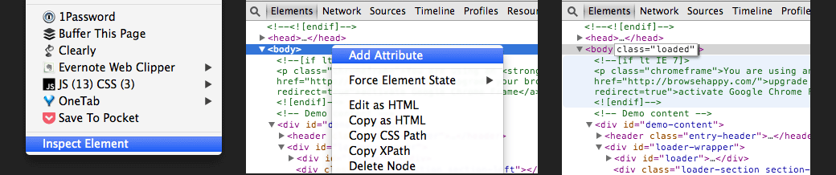
In Google Chrome right click anywhere on the page and click on inspect element, this will bring up the developer tools.
Right click on the body element and add a new attribute class="loaded".
Hit enter and you’ll see our preloader screen disappear.
Great, but hang on, where are the promised CSS3 transitions?
Lets do them in the next step.

4. Order of the animations
Firstly lets get the theory of our transition right.
The order of our animations should be:
- fade #preloader out
- animate both left and right side of the overlay out of the view
- animate the whole #loader-wrapper out of the view
We will fade out the preloader first, by adding CSS3 transitions to #loader.
Tip: you can get the necessary CSS3 code snippet with all the required vendor prefixes from css3please.com.
01  02  03  04  05 | .loaded #loader {  opacity: 0;  -webkit-transition: all 0.3s ease-out;  transition: all 0.3s ease-out;  }

Then we will animate both sides out of a view with a slight 0.3s delay.
01  02  03  04  05  06 | .loaded #loader-wrapper .loader-section.section-right,  .loaded #loader-wrapper .loader-section.section-left {  -webkit-transition: all 0.3s 0.3s ease-out;  transition: all 0.3s 0.3s ease-out;  }

The first 0.3s defines animation duration and the second 0.3s defines the animations delay.
And lastly we will animate the whole #loader-wrapper out of the view using transform: translateY(-100%).
01  02  03  04  05  06  07  08 | .loaded #loader-wrapper {  -webkit-transform: translateY(-100%);  -ms-transform: translateY(-100%);  transform: translateY(-100%);  -webkit-transition: all 0.3s 0.6s ease-out;  transition: all 0.3s 0.6s ease-out;  }

As you can see, here we are setting the delay to 0.6s which is the total duration of our first two animations (0.3 + 0.3 = 0.6).
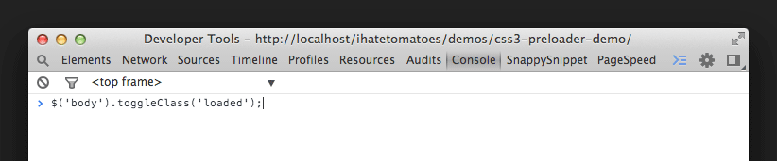
Another way to quickly preview the body class .loaded is to run this line of jQuery code in the web developer console.
01 | $('body').toggleClass('loaded');

This will toggle between our content and the preloader screen animating out.
Pretty cool, huh?

5. Fine tuning

To get even slicker animation for the left and right overlay we can change the easing from ease-out to cubic-bezier and adjust the timing to 0.7s.
01  02  03  04  05  06 | .loaded #loader-wrapper .loader-section.section-right,  .loaded #loader-wrapper .loader-section.section-left {  -webkit-transition: all 0.7s 0.3s cubic-bezier(0.645, 0.045, 0.355, 1.000);  transition: all 0.7s 0.3s cubic-bezier(0.645, 0.045, 0.355, 1.000);  }

Changing the duration of left and right section transition also means that we have to adjust the delay on .loaded #loader-wrapper animation to 1s.
01  02  03  04  05  06  07  08 | .loaded #loader-wrapper {  -webkit-transform: translateY(-100%);  -ms-transform: translateY(-100%);  transform: translateY(-100%);  -webkit-transition: all 0.3s 1s ease-out;  transition: all 0.3s 1s ease-out;  }

6. Fake it till you make it
Because we don’t have enough “heavy” content on our page, we will be faking the loading of the content with a simple jQuery.
You can use imagesloaded by David DeSandro or PxLoader by Pixel Lab on your own projects, but we will have to fake it this time.
Include this code snippet in the js/main.js.
01  02  03  04  05  06  07  08 | $(document).ready(function() {  setTimeout(function(){  $('body').addClass('loaded');  $('h1').css('color','#222222');  }, 3000);  });

That will set the body class to .loaded after 3 seconds and also change the color of our h1 to dark grey.
If you want to learn how to implement imagesLoaded into your project, check out the Simple One Page Template With A Preloading Screen tutorial.

7. No JavaScript, no worries
To ensure that our content is still accessible even without JavaScript being turned on, we can also include the .no-js fallback.
01  02  03  04  05  06 | .no-js #loader-wrapper {  display: none;  }  .no-js h1 {  color: #222222;  }

And that’s it, you’ve made it!
You’ve created a nice animated preloading screen using CSS3 animations and transitions.
Well done!
View Demo →Download Files ↓

Conclusion
What do you think about this simple preloading transition?
Have you seen a cool preloading animation sequence on other sites? Let me know in the comments.

Other preloading tutorials
- A Simple One Page Template With A Preloading Screen
- How To Make Page Transitions in HTML – Barba.js and GSAP3 Tutorial
https://ihatetomatoes.net/create-custom-preloading-screen/

